**The PrisonerGo Project**



Kitdanai Palee

642115004

Jakkaphat Ploylake

642115006

Thanyatorn Noenpoempisut

642115023

Ratchaporn Nuchrungruang

642115040

Sarin Patanompee

642115046

College of Arts, Media and Technology

Chiang Mai University

Present

Asst. Prof. Pattama Longani, Ph.D.

953321 Software Requirement Analysis

Sep 29, 2023

This project is submitted to the Department of Software Engineering,

Chiang Mai University

Table of contents

Introduction and background 3

**Product Request 3**

Problem of the user 3

Goal and Objective 3

Goal 3

Objectives 3

Project Description 4

Benefits 4

Target Users 4

Fishbone diagram 4

**Business review 5**

**Interview 6**

Questions 6

Interviewee #1 7

Mr.Rohin; 38 years old, currently serving a 13 months sentence for DUI (2nd Offense). 7

Interviewee #2 8

Ms.James; 30 years old, serving a 3 years sentence for Non-violent Drug Possession. 8

Interviewee #3 9

Anonymous Prisoner; 27 years old, currently serving a 25 years sentence for Murder. 9

**Features 10**

Feature #1: Online Insurance Application 10

Feature #2: Insurance Status 10

Feature #3: Insuree Status 10

**Cost ($) and Time (months) analysis 10**

**Risk identification and Solutions 10**

Market risk 10

Financial risk 11

Technology risk 11

People risk 12

Structure/Process risk 12

**User Journey - User apply for insurance 13**

**URS 13**

**SRS 13**

**Use case diagram 14**

**Use case description 15**

**Activity diagram 18**

**Non-functional requirement with fit criteria 19**

**UI (wireframe or prototype) 20**

**PrisonerGO**

## Introduction and background

According to the World Prison Brief, Thailand has one of the highest incarceration rates in the world, with 381 prisoners per 100,000 population as of September 2020. The prison conditions in Thailand are poor and often violate the human rights of the inmates. According to a report by Human Rights Watch, inmates face many challenges and abuses in prison.

Prison is a harsh and challenging environment for anyone who has to live there. Inmates face many problems and risks, such as limited access to healthcare services, violence from other inmates or prison staff, and difficulties in reintegrating into society after serving their sentence. These problems can affect their physical, mental, and emotional well-being, as well as their future prospects and opportunities.

To address these problems and provide support and protection for inmates, we propose a new insurance plan that caters to their specific needs and circumstances. This insurance plan is called prisonerGO, and it covers three main aspects of the inmate’s life: health-related problems in prison, rehabilitation, and integration back to society. By offering this insurance plan, we aim to increase the insurance coverage for all types of demographics, bring attention to the safety of inmates, and support their successful reintegration into society.

## Business review

### Problem of the user

* Users may have limited access to healthcare services, and medical issues can be a significant concern.
* There are safety concerns for the users, both from other inmates and prison staff.
* Prison is very uncertain, risky situations can occur at every moment.
* There is no insurance for inmates in the Thailand market.
* Our users may be maltreated by prison staff.
* Users may not have a future after serving their sentence.

### Goal and Objective

#### Goal

Increase insurance coverage for all types of demographics, bring attention to safety of inmates, and support their successful reintegration into society.

#### Objectives

1. Provide users with compensation for health-related problems concerning life in prison, this includes, violence from fellow inmates, or from prison staff.
2. Offer insurance products and services that support the successful reintegration of inmates into society upon release.
3. Cater specific needs and circumstances, policies should address their potential health, legal, and financial needs both inside and outside of prison.
4. Helps inmates in making their time serving a sentence go smoothly.

### Project Description

PrisonerGO is an insurance plan that caters to inmates that are serving a sentence. Inmates or inmates-to-be can apply for our insurance. They may be accepted or denied based on their background, and offense.

This insurance plan covers: (1) Inmate’s health-related problems in prison, (2) Inmate’s rehabilitation, (3) Inmate’s integration back to society.

## Benefits

1. Users can get better healthcare access.
2. Users can integrate back to society after serving their sentence.
3. Users can be compensated for health-related problems concerning life in prison.

### Target Users

The main target users are inmates.

### Fishbone diagram

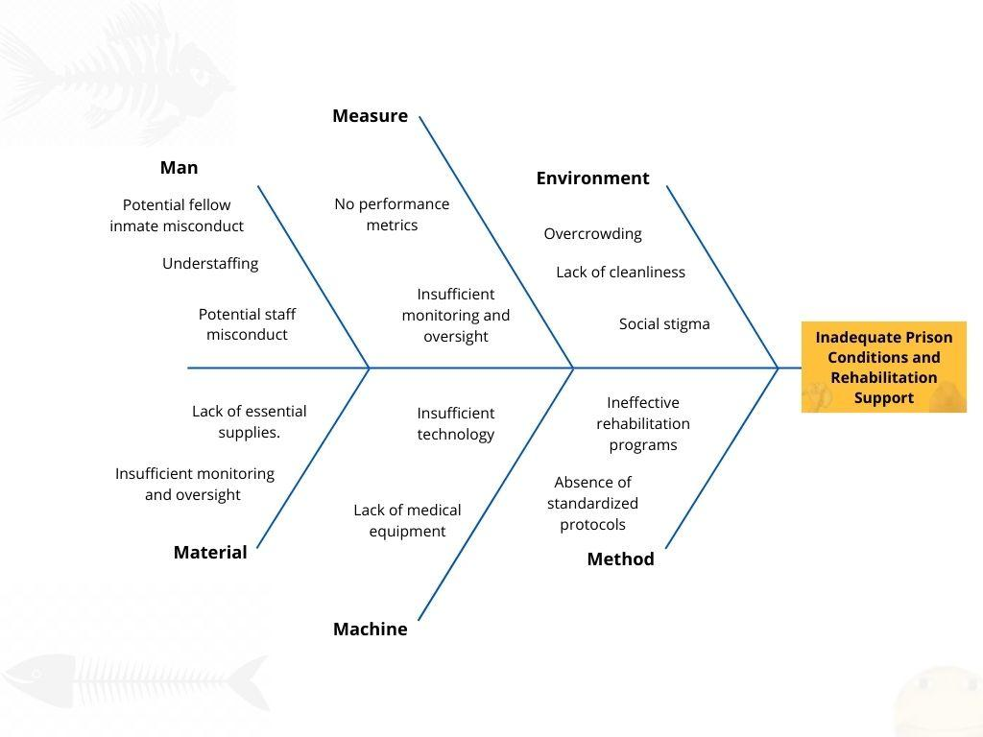

## SWOT analysis

| **Strengths** | **Weakneses** |
| --- | --- |
| * Provides insurance coverage for inmates who have limited access to healthcare services and social welfare * Supports inmates’ rehabilitation and integration back to society after serving their sentence * Offers personalized and flexible insurance plans based on inmates’ needs and circumstances * Uses a web-based system that allows users to apply for the insurance plan online | * High operational costs and risks of providing insurance for inmates * Difficulties in verifying and validating inmates’ information and documents * Lack of awareness and trust among potential customers and stakeholders * Relies on outdated and incompatible technologies that affect the system’s performance and security |
| **Opportunities** | **Threats** |
| * Increasing demand and awareness for social justice and welfare for inmates * Keep an eye on evolving laws and regulations related to inmate welfare and insurance. Changes in legislation may open up new avenues for your insurance services * Use data analysis to identify trends and emerging needs within the inmate population. Data-driven insights can lead to the development of new insurance products that cater to specific requirements. * Partner with community organizations, non-profits, or NGOs focused on inmate rehabilitation and support. Collaborative efforts can help expand your reach and build trust within the inmate community | * Strong competition from other insurance companies that offer similar or better products or services * Changing regulations and policies that may affect the legality or feasibility of the insurance plan * Ethical and legal issues that may arise from providing insurance for inmates * Security breaches or data loss that may compromise the system’s integrity or reputation |

## Type of user

| **User** | | | |
| --- | --- | --- | --- |
| **Prisoner’s relative (Customer)** | | **Admin** | |
| User who is a family member or a friend of an inmate who wants to apply for the prisonerGO insurance plan on behalf of the inmate. | | User who is a staff member of the insurance company that provides the prisonerGO insurance plan. This user can evaluate, approve, or reject the applications, verify and validate the hard copy documents, update the status, and send email notifications to the prisoner’s relatives. | |

## Acronyms and Definition

URS - User Requirement Specification

SRS - System Requirement Specification

UC - Use Case

ID - Identification

## Interview

### Questions

(Diamond structure)

Q1) Have you ever had a health-related problem while in prison? (CLOSED QUESTION)

Q2) Can you describe your experience with healthcare services in prison? (OPEN QUESTION)

Q3) Could you share more about any safety concerns you have had in prison? (OPEN QUESTION)

Q4) Can you elaborate on any instances where you felt maltreated by prison staff? (OPEN QUESTION)

Q5) How do you feel about your future after serving your sentence? (OPEN QUESTION)

Q6) Do you believe an insurance plan like PrisonerGO would be beneficial for inmates? (CLOSE QUESTION)

Q7) Would you consider applying for our insurance plan, PrisonerGO? (CLOSED QUESTION)

### 

### Interviewee #1

### Mr.Rohin; 38 years old, currently serving a 13 months sentence for DUI (2nd Offense).

Q1) Yes, during my time in prison, I did experience a health-related issue. About six months into my sentence, I developed a persistent cough that wouldn't go away. I was eventually diagnosed with bronchitis. It was a challenging experience, and getting access to medical care in prison was not as straightforward as it should have been.

Q2) My experience with healthcare services in prison was mixed. While there were medical staff available, it often took a long time to get an appointment, and the quality of care varied. In some cases, I felt that my concerns were not taken seriously, and there was a lack of transparency about the treatment options available. The overcrowded conditions in the medical facility also made it challenging to maintain social distancing during the COVID-19 pandemic, which added another layer of stress.

Q3) Safety concerns were a constant worry in prison. While I did my best to keep a low profile and avoid trouble, there were still instances of violence and altercations among inmates. Security measures were in place, but they couldn't prevent every incident. It's difficult to feel completely safe when you're confined with a diverse group of people, some of whom may have a history of violence.

Q4) Thankfully, I didn't personally experience severe maltreatment by prison staff. However, I did witness instances where some inmates felt unfairly treated. There were times when staff members seemed dismissive of inmates' concerns or were overly authoritative in their interactions. It's essential for prison staff to treat all inmates with respect and fairness to maintain a safe and humane environment.

Q5) I have mixed feelings about my future after serving my sentence. On one hand, I'm determined to turn my life around and make better choices. However, I'm also aware that reintegration into society can be challenging, especially when you have a criminal record. Finding employment and reestablishing relationships will be difficult, but I'm committed to doing my best to become a productive member of society.

Q6) Yes, I believe an insurance plan like PrisonerGO could be highly beneficial for inmates. It covers essential aspects like healthcare, rehabilitation, and reintegration into society, which are crucial for an inmate's well-being and successful reintegration into society. Many inmates face significant challenges during and after their sentences, and having access to such support can make a meaningful difference in their lives.

Q7) Absolutely, I would consider applying for PrisonerGO insurance. Given the difficulties I've encountered during my sentence and the uncertainties I face upon release, having access to comprehensive support for healthcare, rehabilitation, and reintegration would provide me with a sense of security and a better chance at rebuilding my life. It's reassuring to know that there are programs like this that genuinely care about the well-being of inmates.

### 

### Interviewee #2

### Ms.James; 30 years old, serving a 3 years sentence for Non-violent Drug Possession.

Q1) Yes, I have. During my time in prison, I experienced a few health-related issues, mainly minor illnesses like colds and occasional headaches. Access to medical care has been crucial for addressing these problems, especially considering the crowded conditions.

Q2) Healthcare services in prison have been decent for the most part. The medical staff generally provided the necessary treatment when I needed it. However, there have been times when the healthcare system felt overwhelmed due to the number of inmates seeking medical attention, leading to some delays.

Q3) Safety remains a significant concern in prison, especially given the nature of my non-violent offense. While I haven't experienced direct threats or violence personally, it's still challenging to feel completely secure in this environment, as tensions can escalate quickly among other inmates.

Q4) Fortunately, I haven't personally experienced maltreatment by prison staff. Most of them have treated me fairly and professionally. However, I am aware that such issues can occur in correctional facilities, and it's essential to have mechanisms in place to address them.

Q5) I'm optimistic about my future after serving my shorter sentence. I've been actively working on my rehabilitation, particularly addressing my substance abuse issues. I've also been participating in educational programs that I believe will help me reintegrate into society more smoothly. I'm committed to breaking free from the cycle of addiction and making better choices moving forward.

Q6) Yes, I do believe an insurance plan like PrisonerGO could be beneficial, even for inmates with shorter sentences. It could provide additional support for our healthcare needs and rehabilitation efforts. In my case, it's about preparing for a successful reintegration into society, and any assistance in that regard would be appreciated.

Q7) Absolutely, I would consider applying for PrisonerGO. Given the potential benefits it offers to inmates like myself, it seems like a valuable resource that could help improve our overall well-being and increase our chances of successful reintegration into society, even with a shorter sentence.

### 

### Interviewee #3

### Anonymous Prisoner; 27 years old, currently serving a 25 years sentence for Murder.

Q1) Yes, I have experienced some health-related issues during my time in prison. One of the most significant health challenges I faced was a recurring toothache that became unbearable. It took quite some time to get the dental care I needed, and the pain was extremely distressing.

Q2) Healthcare services in prison have been a source of frustration for me. As I mentioned, it took a long time to receive dental care, and the overall quality of medical attention can vary widely. It's not uncommon to wait for hours or even days to see a healthcare professional, and the conditions in the medical facilities are far from ideal. The focus often seems to be on treating the most severe cases, leaving less urgent medical issues unresolved for extended periods.

Q3) Safety concerns are a constant presence in prison, and I've had my share of worries. Given the nature of my offense and the long sentence, I've had to be vigilant to avoid conflicts with other inmates. It's an environment where tensions can escalate quickly, and security measures don't always prevent violence. It's challenging to feel safe when you're surrounded by individuals with various backgrounds and histories.

Q4) While I can't deny that I've had my disagreements with prison staff, I wouldn't say that I've been subjected to severe maltreatment. However, I have observed instances where staff members could be unnecessarily harsh or dismissive toward inmates. It's crucial for the prison system to prioritize respectful and fair treatment to maintain a sense of justice within the facility.

Q5) My future after serving my sentence looks bleak, to be honest. A 25-year sentence for murder is a significant burden to carry, and I know that reintegration into society will be extremely challenging. Finding employment, building relationships, and regaining trust will be formidable hurdles to overcome. I'm apprehensive about the road ahead, but I'm committed to working on personal growth and rehabilitation during my time in prison.

Q6) Yes, I do think an insurance plan like PrisonerGO could provide essential support for inmates. While my circumstances are different from others, I recognize that many inmates face a range of challenges, including healthcare needs, rehabilitation, and reintegration into society. Such a comprehensive support system could be beneficial in addressing these issues and giving inmates a better chance at a successful post-prison life.

Q7) Given my long sentence and the nature of my offense, I'm uncertain if I would be eligible for PrisonerGO insurance. However, if I were eligible, I would consider applying. The prospect of having access to healthcare, rehabilitation, and reintegration support could potentially help improve my quality of life during my time in prison and offer a glimmer of hope for a better future upon release.

## 

## 

## Features

### Feature #1: Online Insurance Application

Families of inmates can complete the online insurance application process by providing essential inmate details, including date of birth, sentence details, personal health status, and substance use history. Additionally, applicants are required to furnish their personal information, including name, surname, gender, and marital status, along with their contact details, encompassing address, phone number, and email address. The final step involves completing a relative information form, specifying the relative's name, their relation to the inmate, and also the relative’s email while also indicating the nature of the inmate's case, with the exception of mailing hard copies of personal documents for validation purposes.

### Feature #2: Insurance Status

Family members of inmates can access comprehensive details regarding their insurance contracts and their real-time status by utilizing the 'Track and Trace' feature on our website. To access this information, relatives can conveniently search for the inmate's unique identification number, which is generated upon the successful completion of all required information and is also sent to their registered email.

### Feature #3: Insuree Status

Inmate’s relatives can view the status of the insuree (inmate) while the insurance contract is valid and the inmate is under our program. The status includes their latest health report, their rehabilitation progress and policy details.

## Cost (THB) and Time (months) analysis

| Name | Role | Phase 1 | | Phase 2 | | Phase 3 | |
| --- | --- | --- | --- | --- | --- | --- | --- |
| Cost | Time | Cost | Time | Cost | Time |
| Kitdanai | Business Analyst | 300,000 | 6 | 0 | 0 | 0 | 0 |
| Jakkaphat | Software Developer | 600,000 | 6 | 400,000 | 4 | 0 | 0 |
| Thanyatorn | UX/UI Designer | 450,000 | 6 | 450,000 | 6 | 300,000 | 4 |
| Ratchaporn | QA Engineer | 0 | 0 | 300,000 | 6 | 200,000 | 4 |
| Sarin | System Administrator | 0 | 0 | 0 | 0 | 300,000 | 4 |

## Technology Cost

| Technology | Cost (THB) |
| --- | --- |
| Google Cloud Platform Hosting  [Estimate Reference](https://cloud.google.com/products/calculator/#id=bee58b20-d0c8-48c8-b495-b393f93a00b2) | 6,340/month |

## SDLC

We are using the waterfall model.

## 

## 

## 

## 

## Risk identification and Solutions

### Market risk

| **Risk ID** | **Header** | **Decription** | **Priority Level** | **Impact** | **Likelihood od Event** | **Mitigation Strategy** |
| --- | --- | --- | --- | --- | --- | --- |
| M-1 | Increased Costs for Inmate Insurance | Providing comprehensive healthcare, rehabilitation, and reintegration support can lead to increased costs for the insurance plan, potentially affecting pricing and market competitiveness. | H | Higher premiums may deter potential users, reducing the insurance plan's market penetration. | Moderate | Conduct a thorough cost-benefit analysis to strike a balance between offering comprehensive services and maintaining affordability. Seek partnerships or grants to supplement funding. |
| M-2 | Competitive Market for Inmate Insurance | The market for inmate insurance may be competitive, with other insurance providers or programs offering similar services to inmates. | N | High competition could result in pricing pressures, making it challenging for PrisonerGO to maintain affordability while providing comprehensive services. | High | Conduct a thorough competitive analysis to identify unique value propositions and pricing strategies. Continuously monitor the market and adapt offerings to remain competitive. Explore partnerships with correctional facilities for exclusive agreements. |

### Financial risk

| **Risk ID** | **Header** | **Decription** | **Priority Level** | **Impact** | **Likelihood od Event** | **Mitigation Strategy** |
| --- | --- | --- | --- | --- | --- | --- |
| F-1 | Resource Constraints in Correctional Facilities | Correctional facilities may face resource constraints in implementing rehabilitation and support programs, including staff shortages, facility limitations, and budget constraints. | H | Limited resources could hinder the effective delivery of rehabilitation services, potentially reducing their impact | High | Advocate for increased funding for correctional facilities to support the implementation of rehabilitation programs. Explore cost-effective program delivery methods. |

### Technology risk

| **Risk ID** | **Header** | **Decription** | **Priority Level** | **Impact** | **Likelihood od Event** | **Mitigation Strategy** |
| --- | --- | --- | --- | --- | --- | --- |
| T-1 | Data Privacy and Security | Managing inmates' personal information and ensuring data privacy within a prison environment can be challenging, potentially leading to breaches of confidentiality. | H | Data breaches could expose sensitive inmate information, eroding trust in the insurance plan. | Moderate | Implement robust data encryption and access controls. Train staff on data privacy best practices and conduct regular security audits. |

### People risk

| **Risk ID** | **Header** | **Decription** | **Priority Level** | **Impact** | **Likelihood od Event** | **Mitigation Strategy** |
| --- | --- | --- | --- | --- | --- | --- |
| P-1 | Public Resistance to Reentry Programs | Some communities may resist the placement of reentry programs and supportive housing for released inmates, potentially creating friction with local residents. | N | Community resistance could hinder the successful implementation of reentry initiatives. | Moderate | Engage with local communities through public awareness campaigns, community meetings, and collaboration with local leaders to address concerns and build support. |

### Structure/Process risk

| **Risk ID** | **Header** | **Decription** | **Priority Level** | **Impact** | **Likelihood od Event** | **Mitigation Strategy** |
| --- | --- | --- | --- | --- | --- | --- |
| S-1 | Bureaucratic Hurdles in Program Implementation | Complex application and approval processes for support services can create bureaucratic hurdles and delays in inmates receiving necessary assistance. | N | Bureaucratic hurdles may frustrate inmates, potentially affecting their motivation to participate in rehabilitation programs. | High | Streamline and simplify application processes, reduce paperwork, and provide support staff to assist inmates in navigating the system. |

## 

## User Journey - User apply for insurance



## URS

URS-001: Users should be able to enter preliminary information **which are date of birth, sentence details, personal health, and substance use history**

URS-002: Users should be able to enter personal information **which are name, surname, address, gender, martial status, Phone number, and email**

URS-002: Users should be able to view the insurance quote **which are pricing information, coverage details, policy terms, discounts deductions, policy options, underwriting information, and comparison tools**

URS-003: Users should be able sent a confirmation through email and be able to check status.

URS-004: Users should be able to view and sign the insurance contract and the content of the documents **inside are Insurance Application and Policy Agreement, Informed Consent and Disclosure Form, Authorization for Premium Deductions, Beneficiary Designation Form ,Release of Information Form,Compliance and Reporting Form, andCancellation or Termination Request**

## SRS

SRS-01: System should provide user status whether they are able to use the insurance by checking the preliminary information, and personal information.

SRS-02: System should give preliminary information on whether the user is applicable.

SRS-03: System should keep user information for background checks by using the id of the registered inmate.

SRS-04: System can display insurance quotes.

SRS-05: System can send email notifications for status confirmation of the registered inmate.

SRS-06: System can receive signed documents from users through upload by files .

## Use case diagram

## 

## Use case description

| Use Case ID | UC-01 | | | |
| --- | --- | --- | --- | --- |
| Use Case Name | User can apply for insurance | | | |
| Created By | PrisonerGO Collective | | Last Update By | PrisonerGO Collective |
| Date Created | 18/09/2023 | | Last Revision Date | 18/09/2023 |
| Actors | User, System, Admin | | | |
| Description | This system enables users to access our website and initiate the insurance contract application process. Users input preliminary information, receive eligibility feedback, submit detailed information, and provide necessary personal documents. These documents undergo inspection, with results returned within a week. Upon approval, users digitally sign the insurance contract, completing the application process. | | | |
| Trigger | User enters the Apply page | | | |
| Preconditions | All systems are working properly, User can send mail, User is not the person being incarcerated. | | | |
| Use Case Input Specification | | | | |
| Input | type | Constraint | | Example |
| Offense | String | From given choices | | DUI - 1st offense |
| Age | Integer | Age > 0 | | 28 |
| Previous Conditions. | String[] | From given choices | | [Asthma, Arthritis] |
| Smoke | Boolean |  | | False |
| Post conditions |  | | | |
| Normal Flows | User | | System | |
| N-1 | 1. The user inputs preliminary information | |  | |
| N-2 | 2. The user submits their anonymous information   * Age * Weight * Height * Sentences * Health Condition | | 3. Show preliminary evaluation  (A-1) | |
| N-3 | 4. The user inputs personal/detailed information   * Name * Address * Family members’ information | |  | |
| N-4 | 5. The user submits the information | | 6. Calculate and display the insurance quote  (A-2, E-1) | |
| N-5 |  | | 7. Show shipping information for hard-copy of personal documents | |
| N-6 | 8. The user mails hard-copy of personal documents to our company   * Copy of Thai House Registration and Resident Book * Copy of insuree ID and user’s ID | | 9. Admin evaluates the result by consulting documents with government officials’ and looking through criminal records | |
| N-7 | 11. The user views the insurance contract | | 10. Email the result to the user  (A-3) | |
| N-8 | 12. The user signs the insurance contract and uploads  (A-4) | | 13. Store the signed contract and add the user to insuree database | |
| Alternative Flow | A-1: Rejected   1. System shows rejected screen   A-2: Rejected   1. System shows rejected screen   A-3: Rejected   1. System shows rejected page 2. System deletes all stored information from the user   A-4: User hasn’t signed the contract after 14 days   1. System deletes all stored information from the user | | | |
| Exception Flow | E-1: The quote cannot be calculated due to any problem   1. Show quote unavailable frame 2. Redirects the user back and prompts them to retry (N-3 (4)) | | | |
| Assumption | User offenses are at acceptable degree | | | |
|  |  |  |  |  |

## 

## Activity diagram

## 

Source: [Activity-Diagram-PrisonerGo.jpg](https://drive.google.com/file/d/15W76kgzMXCDEBgZqCJjxt1QM5voBU-u_/view?usp=sharing)

## 

## Non-functional requirement with fit criteria

1. **Security and Compliance:**

**Compliance**: Ensure 100% compliance with all relevant legal and regulatory requirements in your jurisdiction(s).

1. **Scalability:**

**Elasticity:** The system should be able to handle a 20% increase in the number of policyholders and claims without a significant increase in response time.

1. **Performance:**

**Response Time:** Maintain an average response time for user interactions (e.g., insurance quote calculation) of less than 3 seconds.

**Throughput:** Support a minimum of 1,000 simultaneous requests and inquiries during peak hours.

1. **Reliability:**

**Uptime:** Maintain at least 99.5% system uptime during business hours.

**Disaster Recovery:** Achieve a recovery time objective (RTO) of no more than 4 hours in case of system failures.

1. **Usability:**

**Accessibility:** Ensure compliance with WCAG 2.1 AA accessibility standards.

## UI (wireframe or prototype)

UI-01 Home page

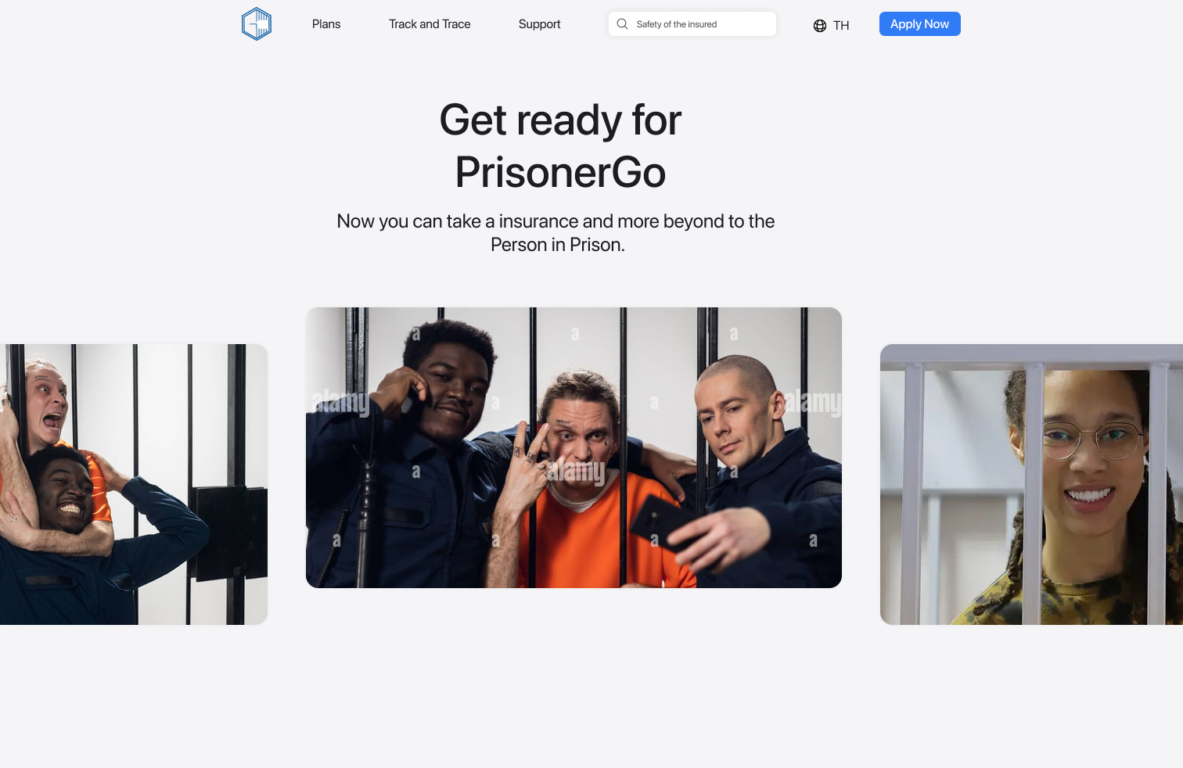

UI-02 Preliminary Information form

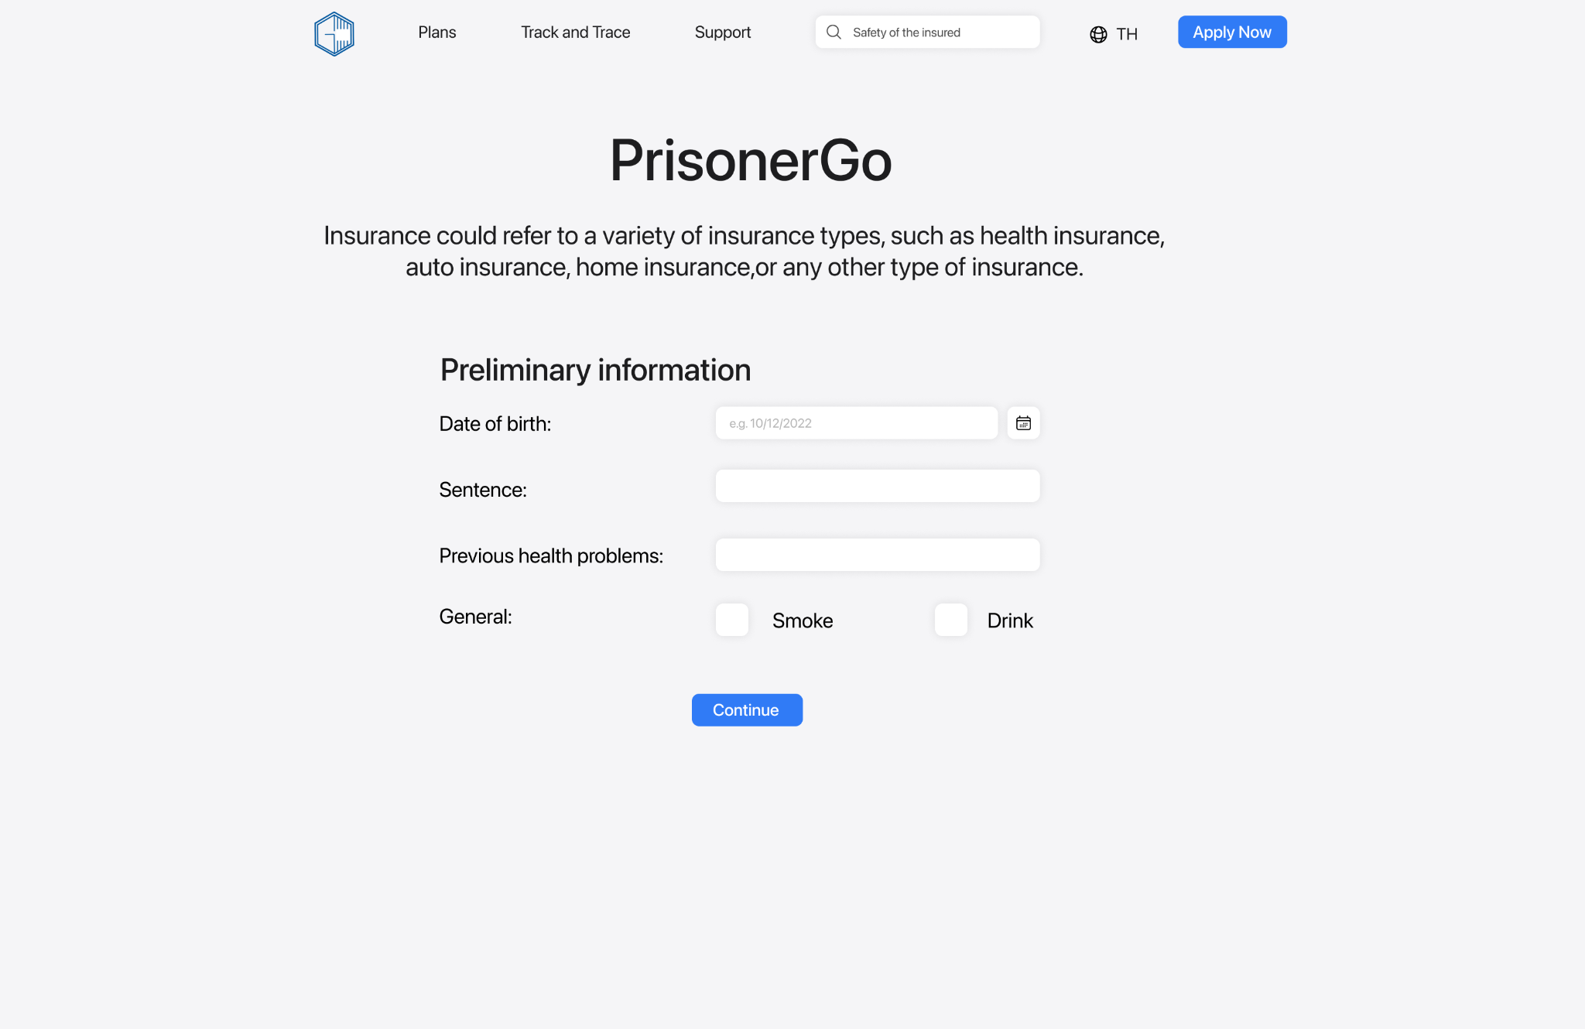

UI-02-01 Preliminary Information form and click calendar button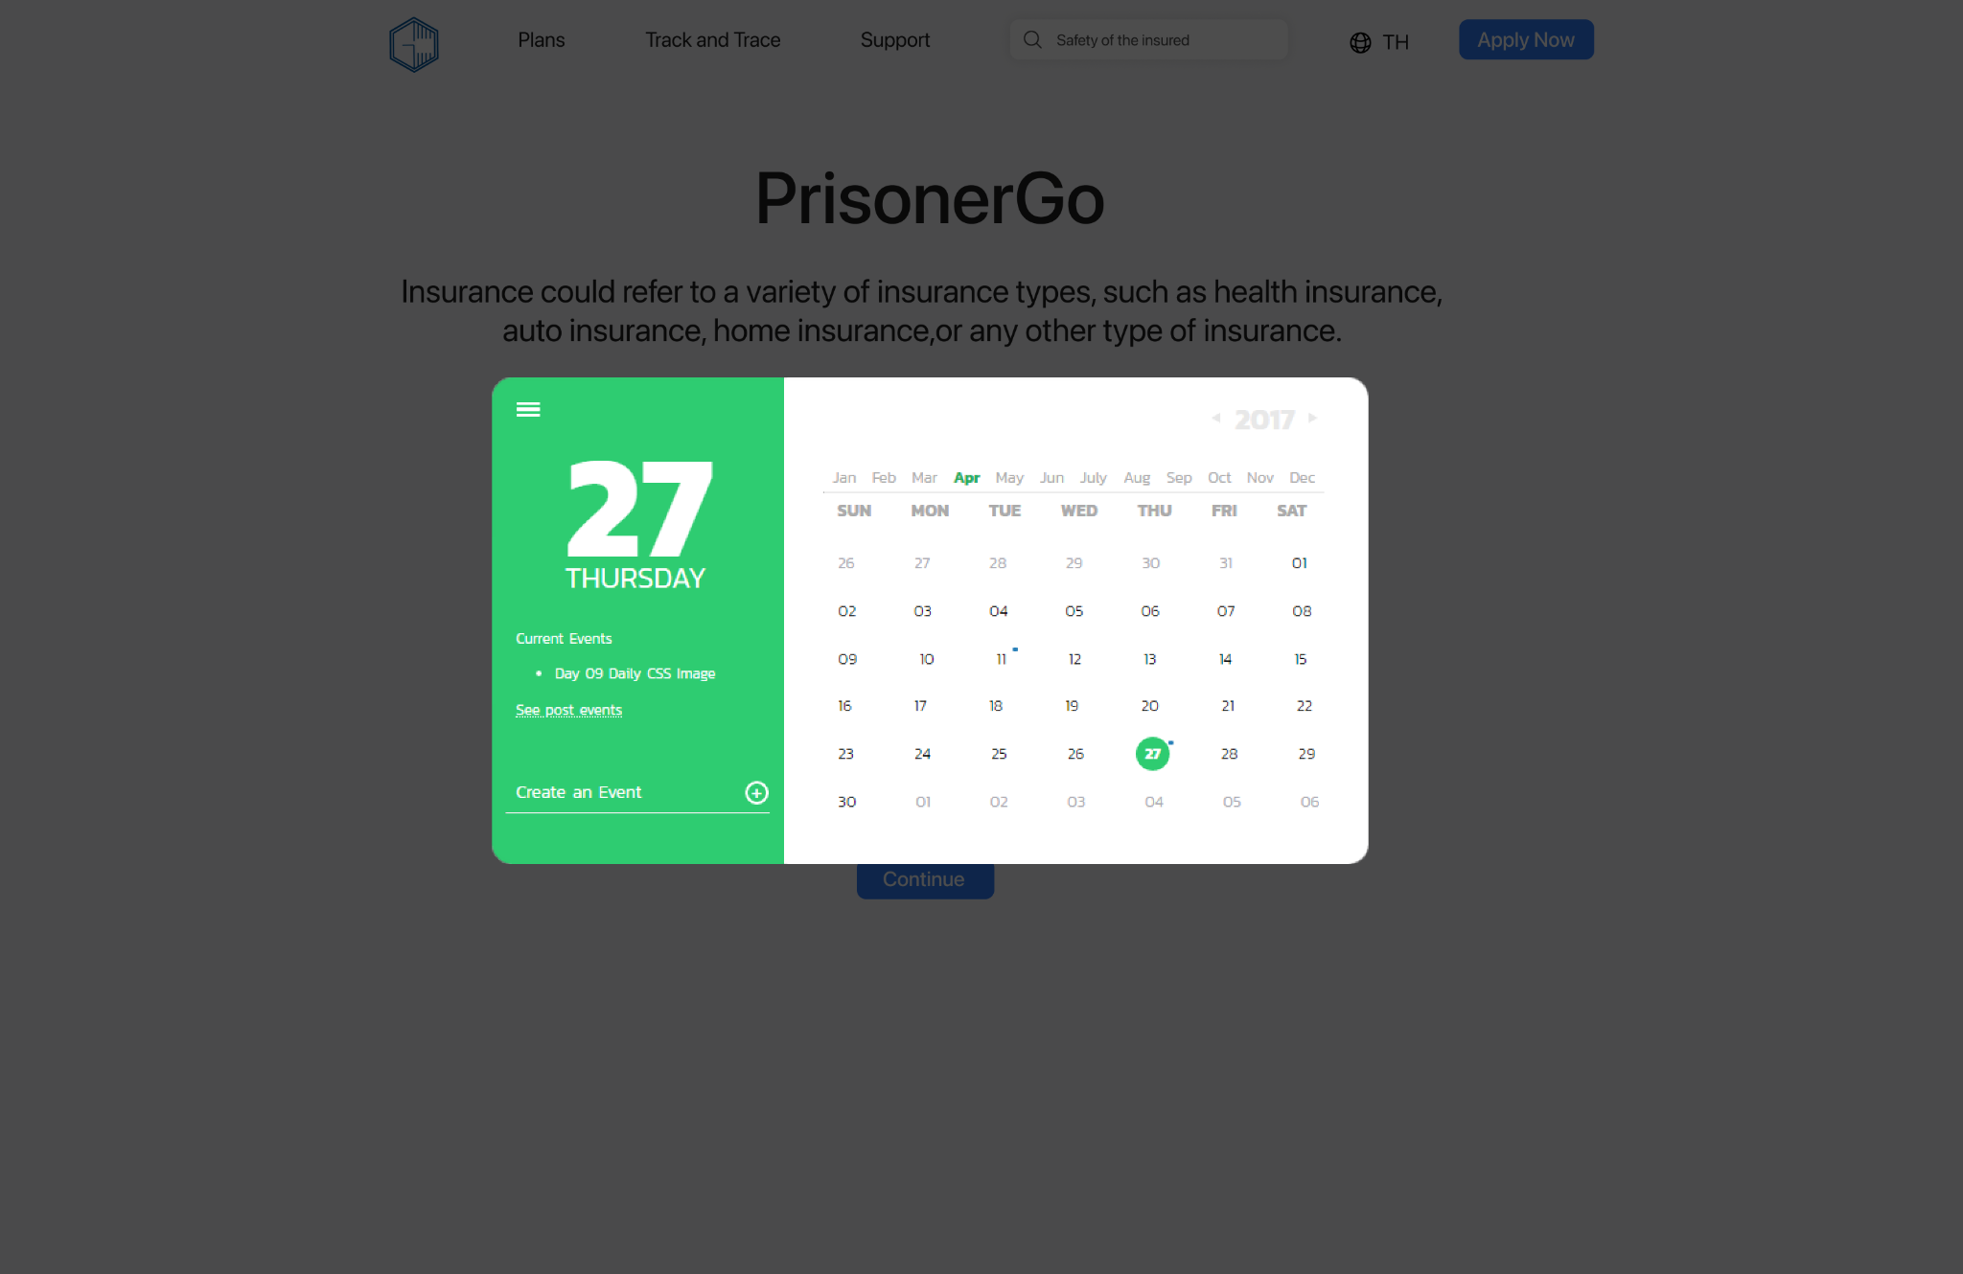

UI-02-02 Preliminary Information form and click sentence input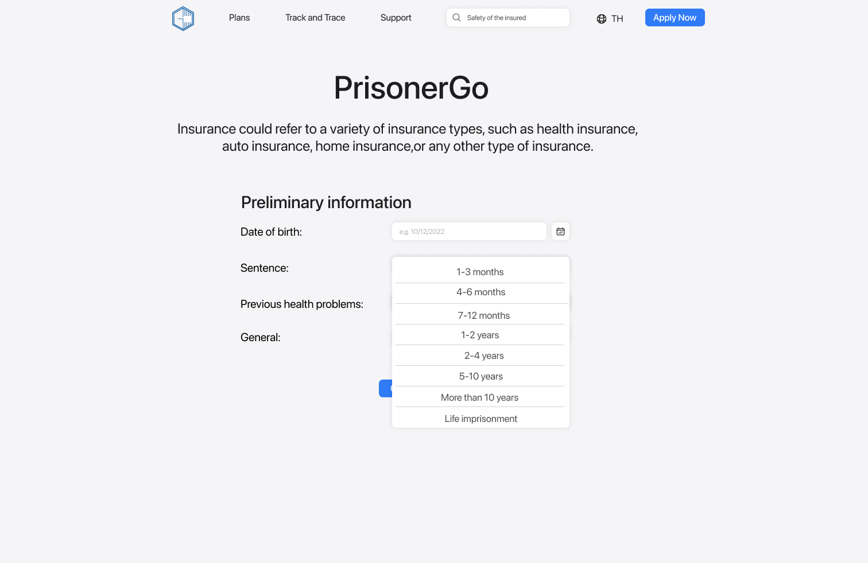

UI-02-03 Preliminary Information form and click tick box (drink & smoke)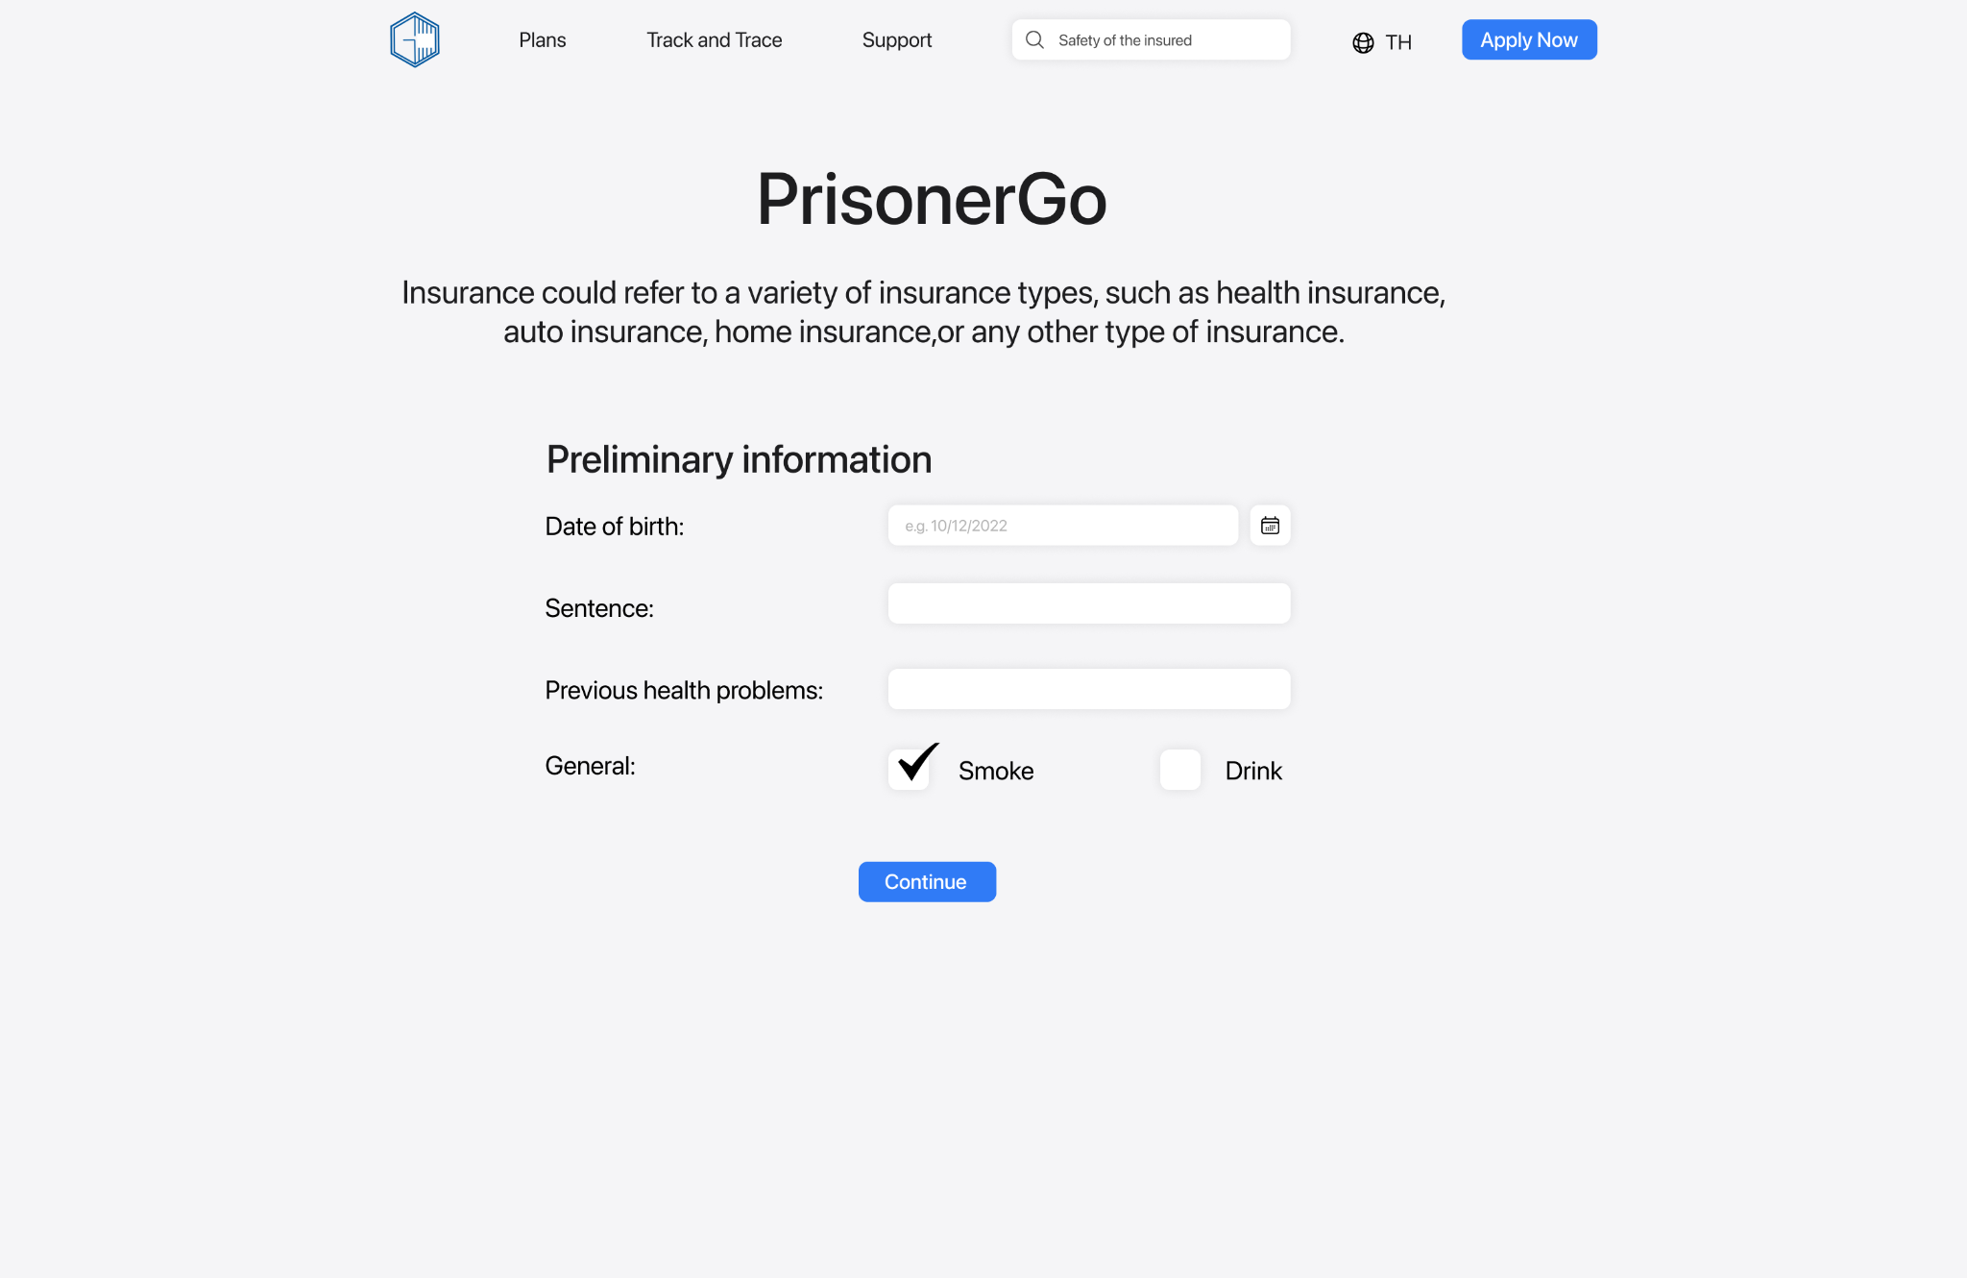

UI-03 Detailed information form

UI-04 Quote display page

UI-05 Insurance Contract page

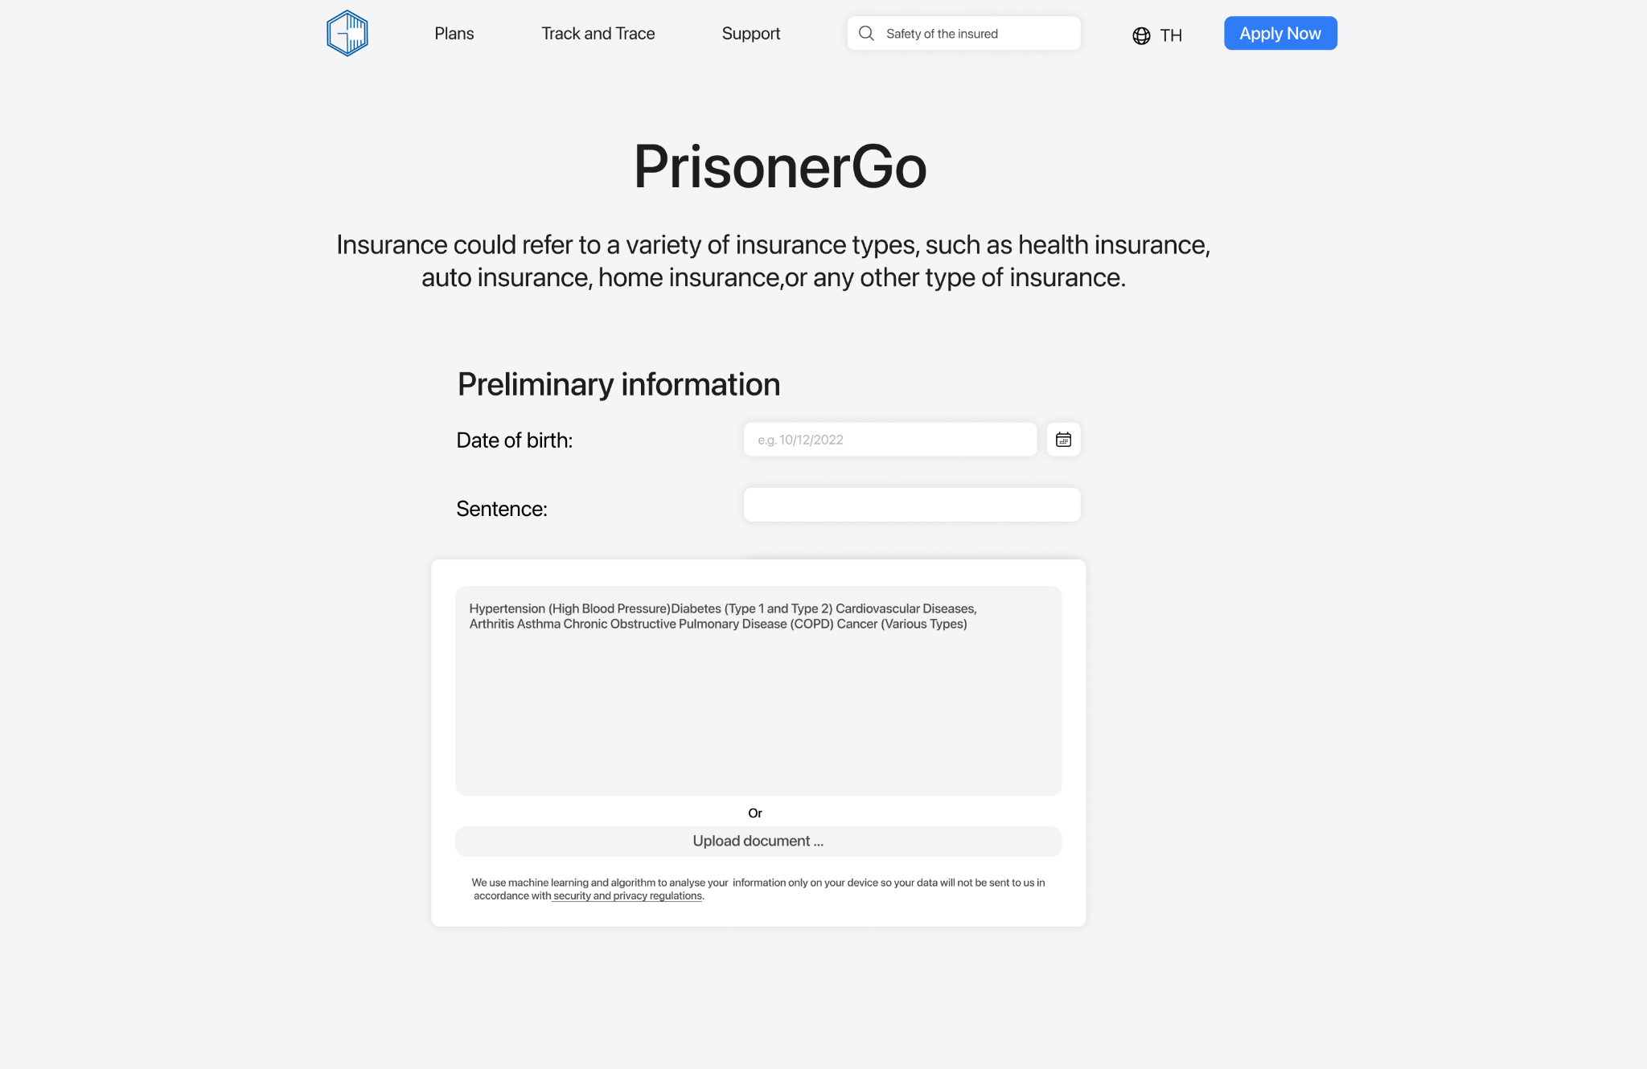

UI-02-04 Preliminary Information form and click tick box (drink & smoke)

UI-03-01 Quote display page

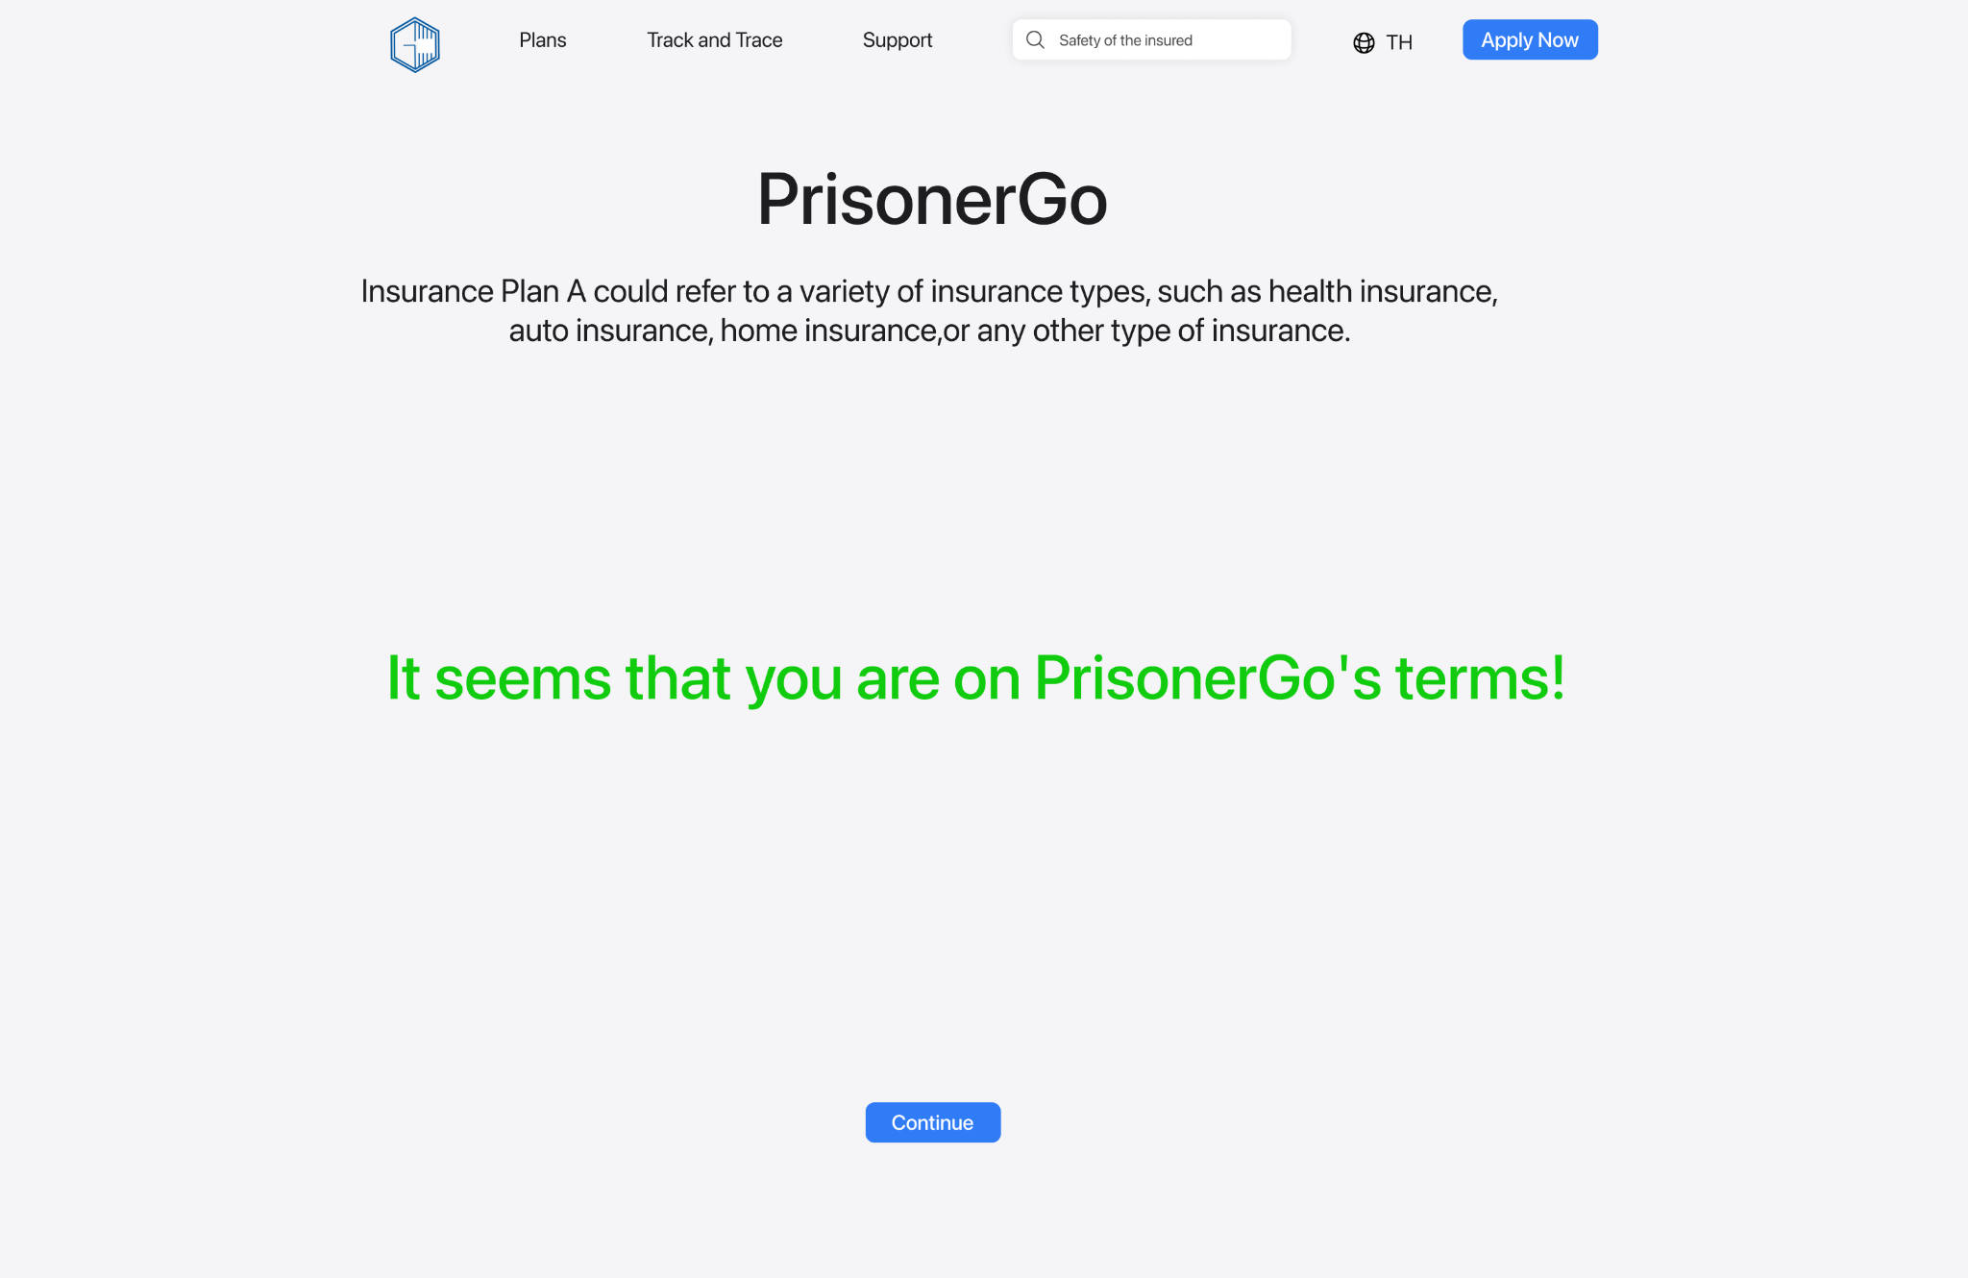

UI-03-02 Quote reject display page

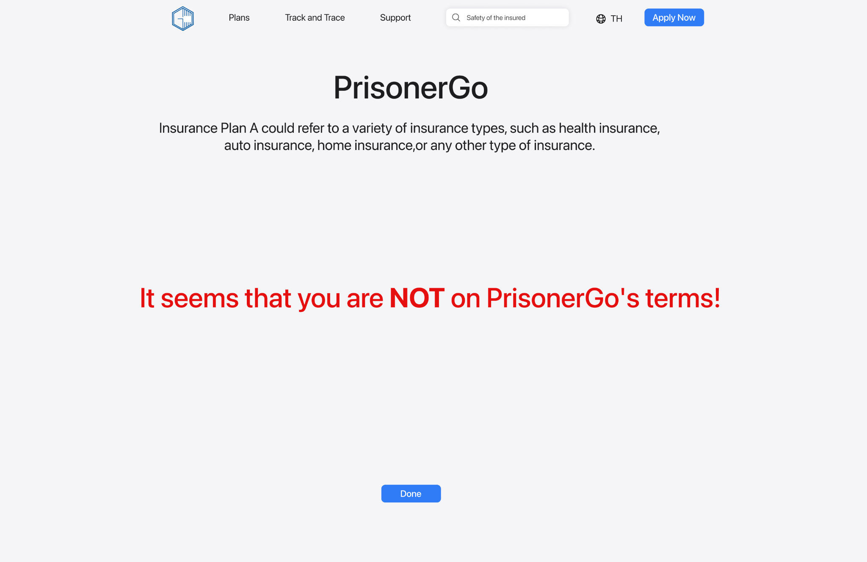

UI-04-01 Detailed information form

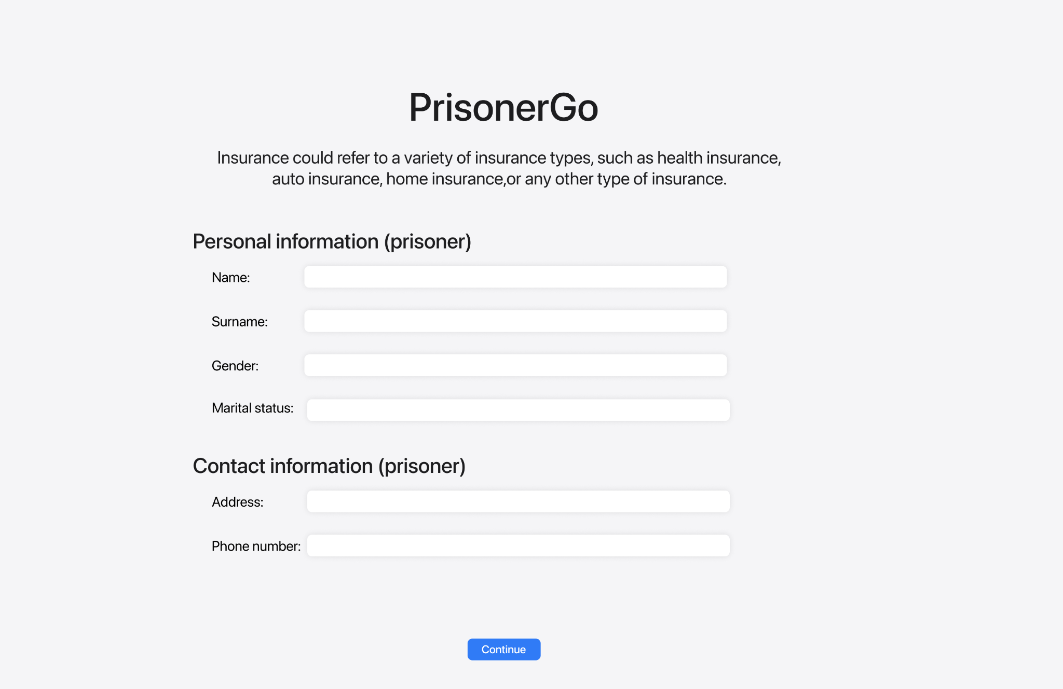

UI-04-02 Detailed information form of relative’s prisoner

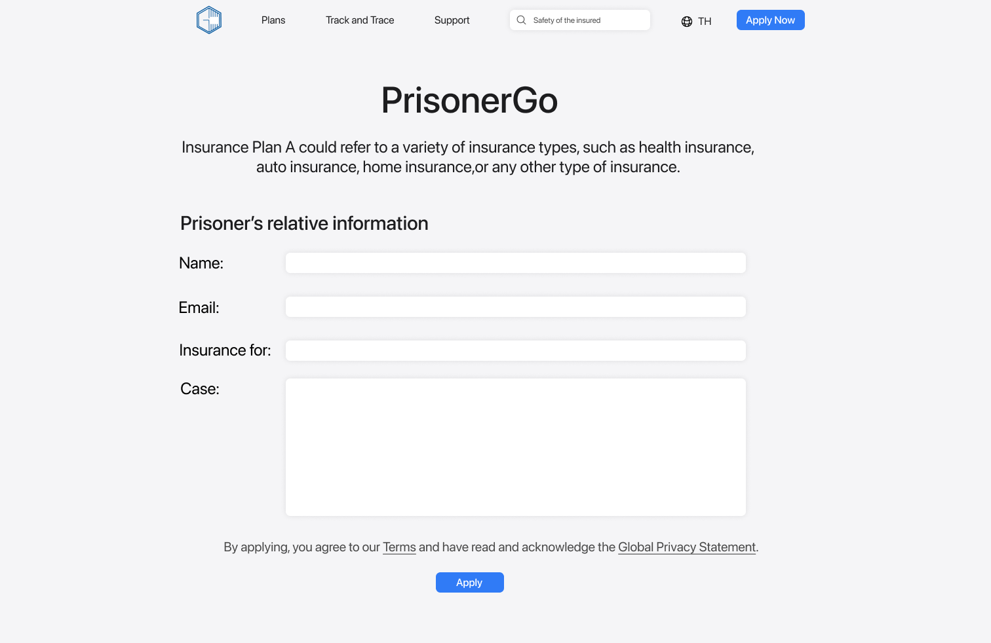

UI-05 Insurance Quote Page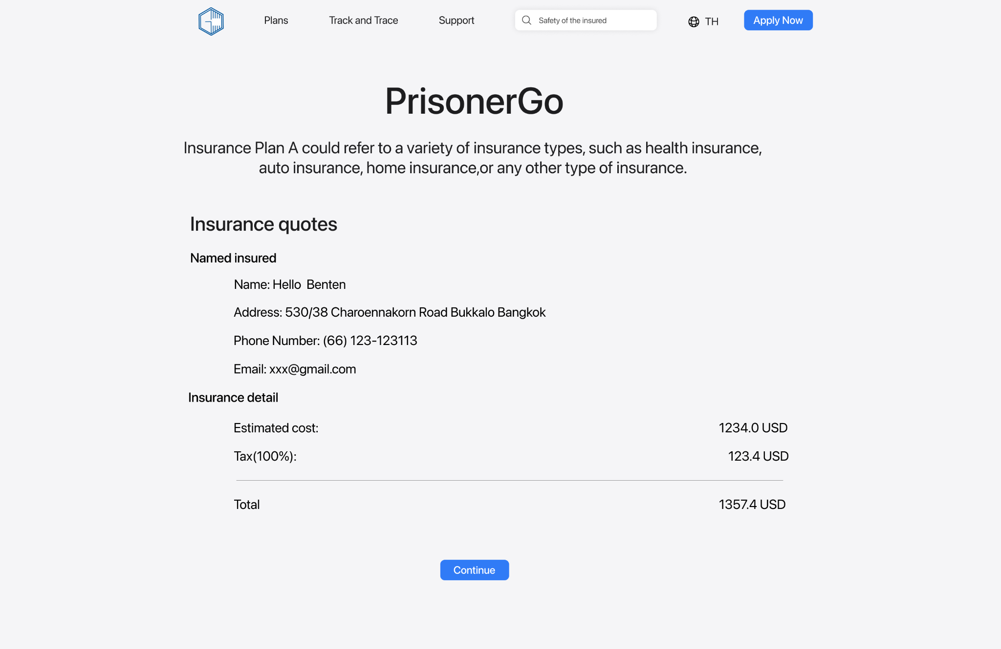

UI-06 Detailed information form of relative’s prisoner

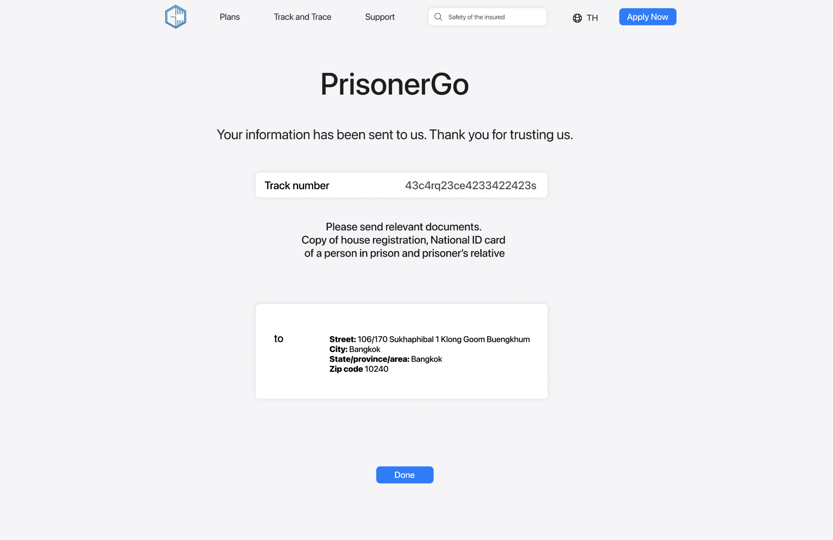

UI-07 Insurance Contract page

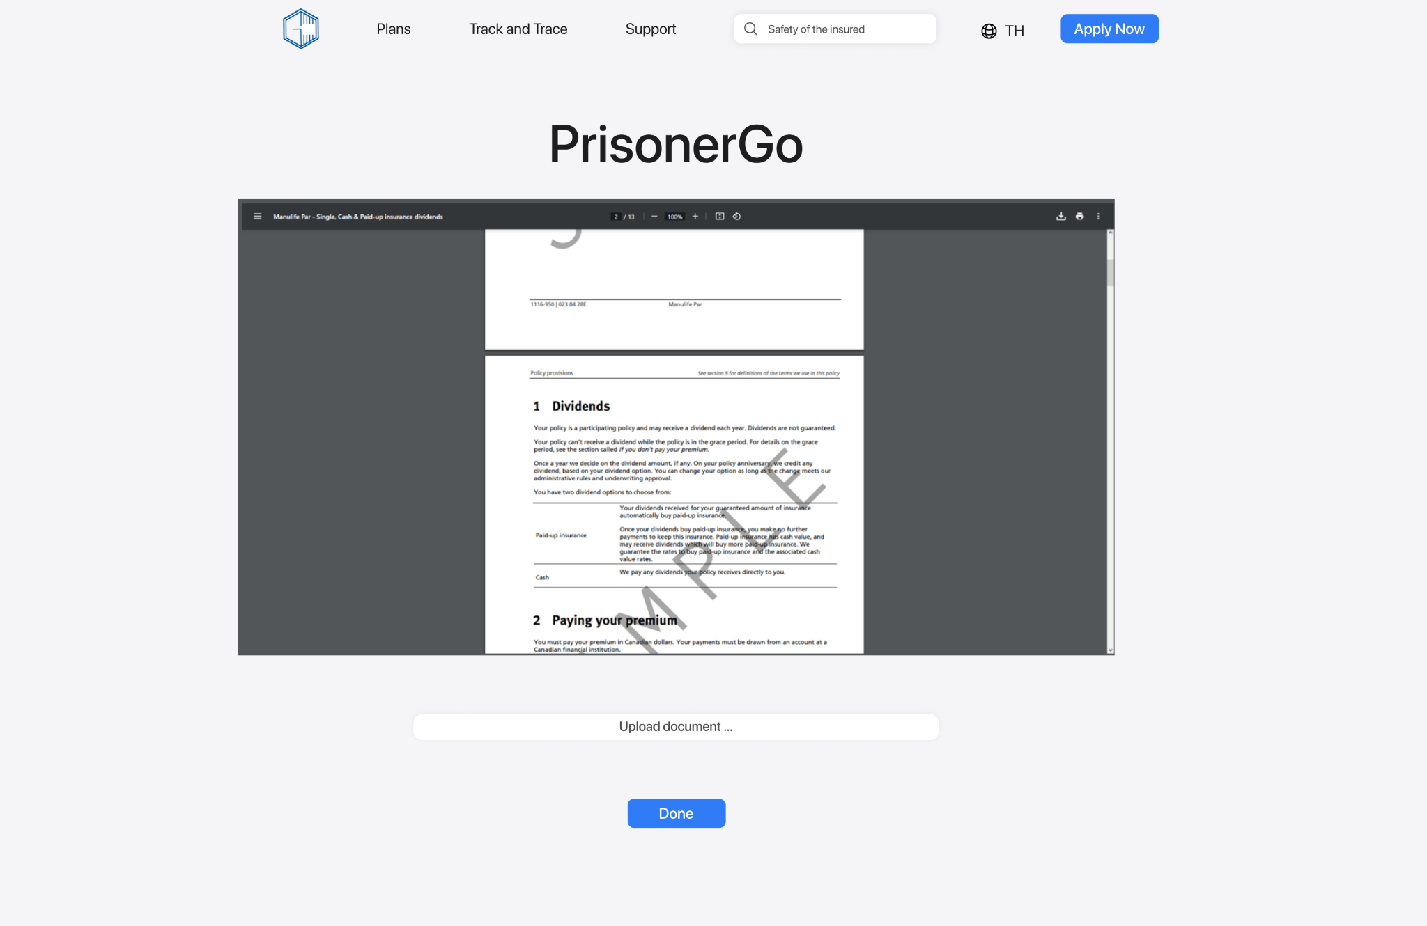

UI-08 Rejected page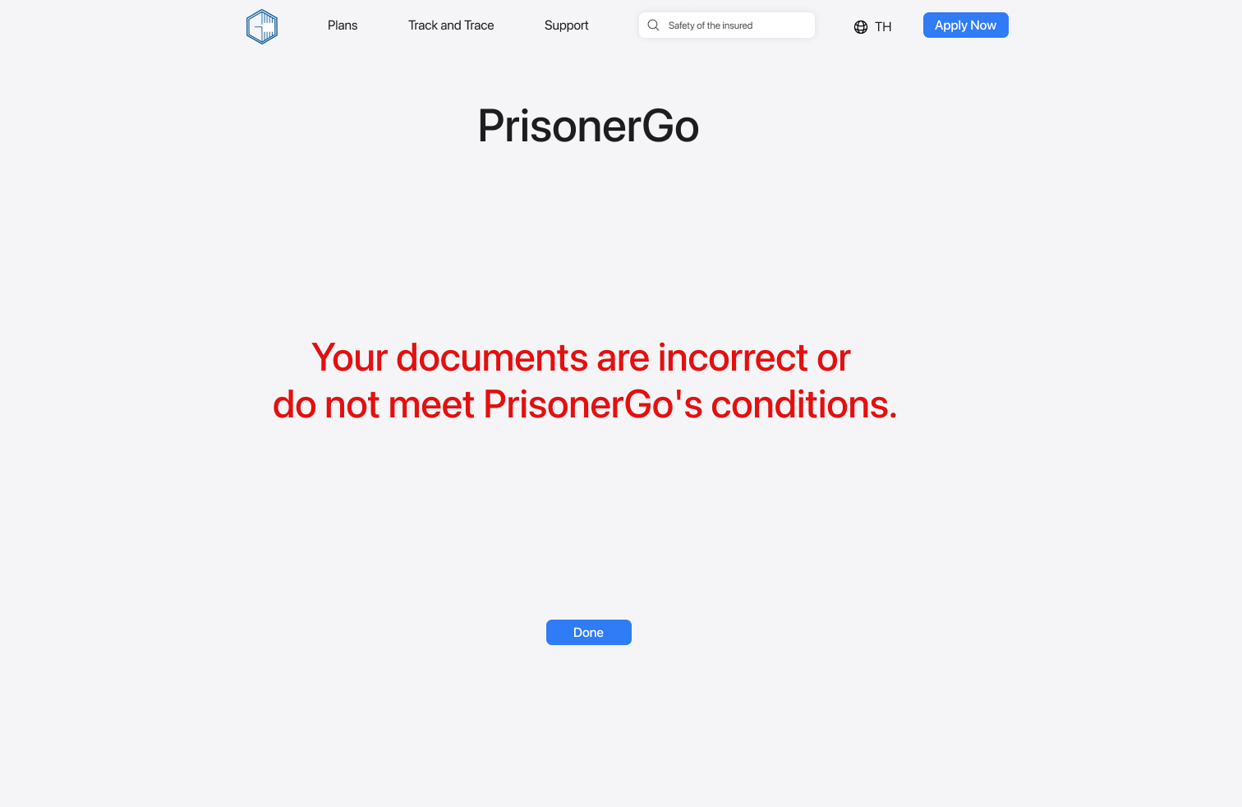

## 

UI-09-01 Track Application Status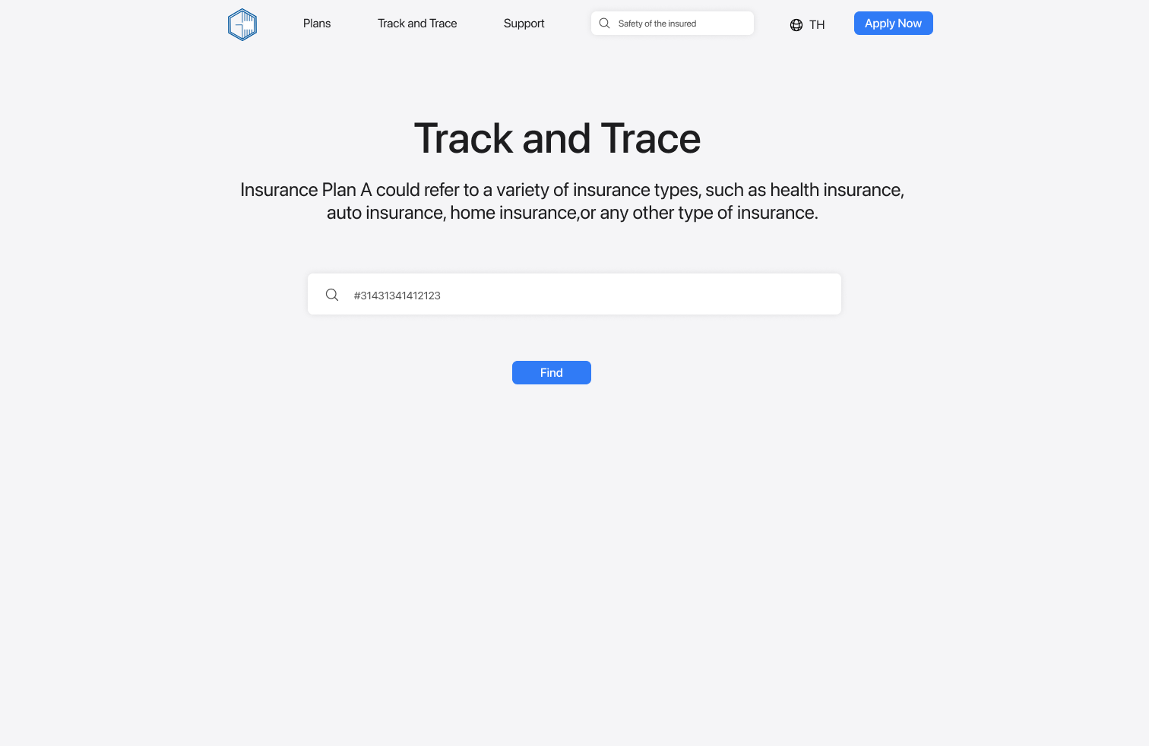UI-09-02 Application Status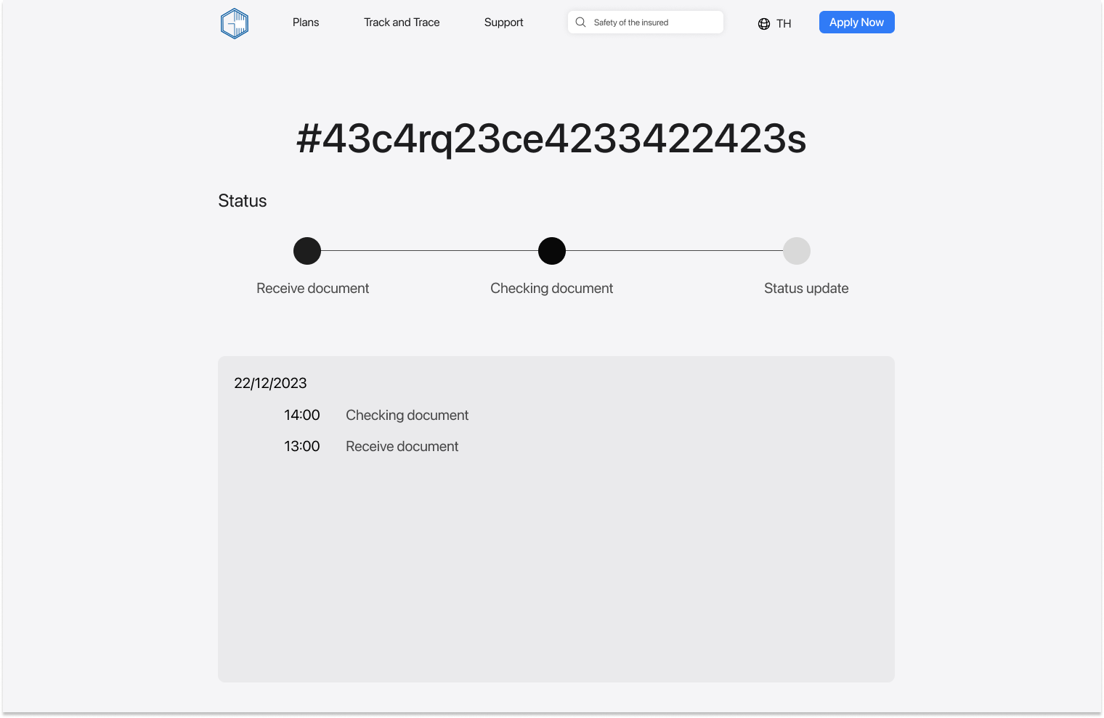

## Traceability Matrix

| URS-SRS | SRS-01 | SRS-02 | SRS-03 | SRS-04 | SRS-05 | SRS-06 |
| --- | --- | --- | --- | --- | --- | --- |
| URS-001 |  |  |  |  |  |  |
| URS-002 |  |  |  |  |  |  |
| URS-003 |  |  |  |  |  |  |
| URS-004 |  |  |  |  |  |  |

| URS-UI | UI-01 | UI-02 | UI-03 | UI-04 | UI-05 | UI-06 | UI-07 | UI-08 |
| --- | --- | --- | --- | --- | --- | --- | --- | --- |
| URS-001 |  |  |  |  |  |  |  |  |
| URS-002 |  |  |  |  |  |  |  |  |
| URS-003 |  |  |  |  |  |  |  |  |
| URS-004 |  |  |  |  |  |  |  |  |

| SRS-UI | UI-01 | UI-02 | UI-03 | UI-04 | UI-05 | UI-06 |
| --- | --- | --- | --- | --- | --- | --- |
| SRS-01 |  |  |  |  |  |  |
| SRS-02 |  |  |  |  |  |  |
| SRS-03 |  |  |  |  |  |  |
| SRS-04 |  |  |  |  |  |  |
| SRS-05 |  |  |  |  |  |  |
| SRS-06 |  |  |  |  |  |  |